# **OnFest**

# Created on March 02 2018

# **Table of Contents**

1.0. Home

2.0. Register

3.0. Log in

# **1.0. Home**

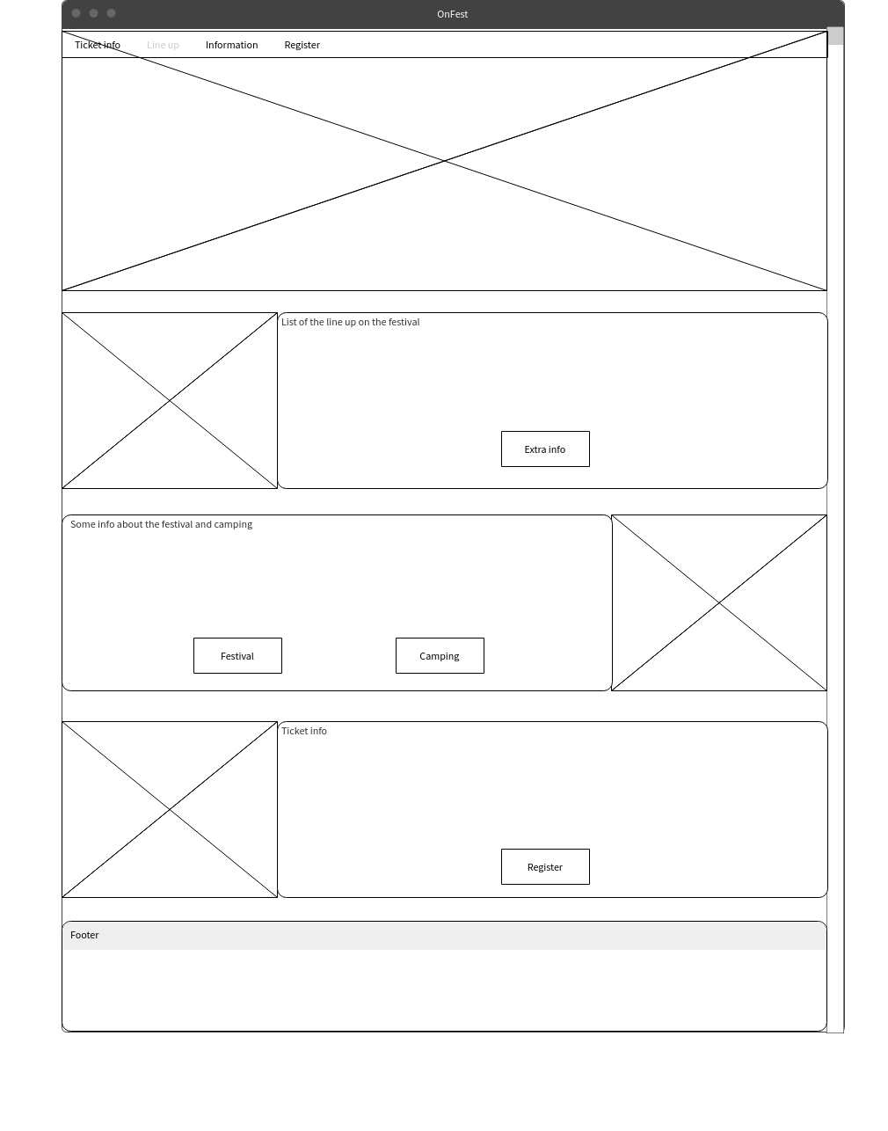

# **2.0. Register**

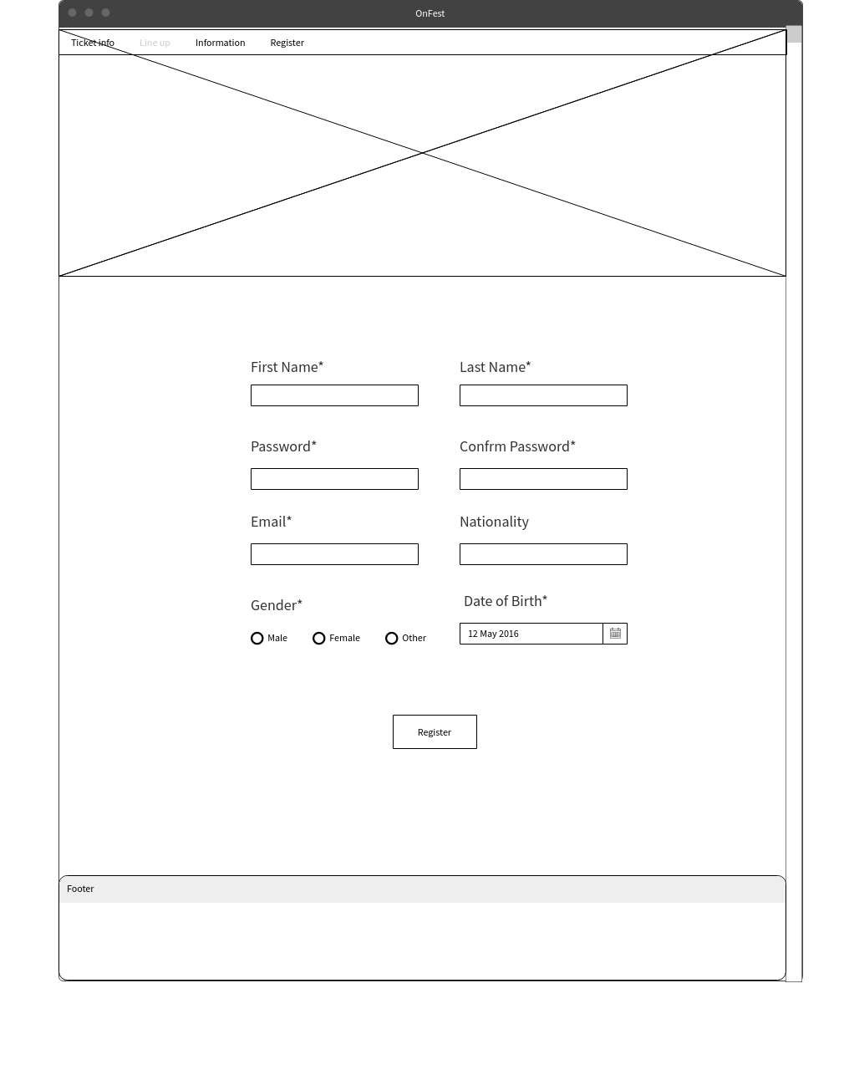

# **3.0. Log in**

